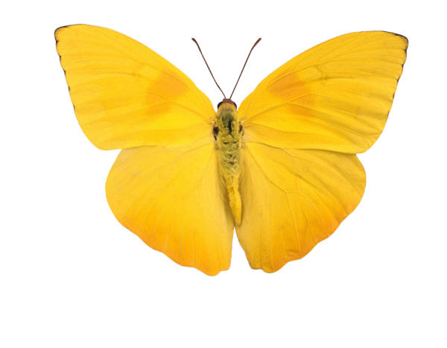

* **Bugs, Bugs, Bugs: 21 Songs and Over 250 Activities for Young Children - Pam Schiller**
* **Deep Nature Play - Joseph Cornell**
* **How to Raise a Wild Child - Scott Sampson**
* **Last Child in the Woods – Richard Louv**
* **Learning is in Bloom - Ruth Wilson**
* **Nature and Young Children - Ruth Wilson**
* **Nature-Based Learning for Young Children: Anytime, Anywhere, on Any Budget - Julie Powers and Sheila Williams Ridge**
* **The Nature Connection – Claire Walker Leslie**
* **The Nature Fix – Florence Williams**
* **Nature Play at Home: A Guide for Boosting Children's Healthy Development and Creativity – National Learning Initiative**
* **Sharing Nature – Joseph Cornell**
* **Teaching STEM Outdoors – Patty Born Selly**
* **Wild Play – David Sobel**
* **Wings, Worms, and Wonder – Kelly Johnson**
* **Wings, Worms, and Wonder – Kelly Johnson**

**Nature Books for Parents**